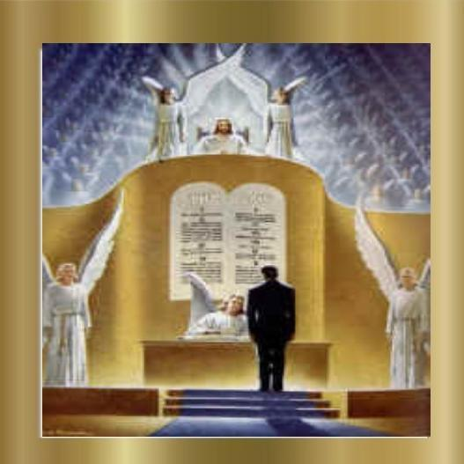

Riots, riots and more riots; every day in Democratically controlled cities we see RIOTS! People just don’t get it; they actually think it is OK to riot. How does a person become an adult and NOT realize that if you do something wrong there will be a punishment – someday? One thing is sure; no society can long endure if lawlessness is permitted and punishment is nonexistent.

I wonder, do the people who riot live their lives in such a manner? Do they practice violence as a way of life or steal or abuse their neighbors or destroy not only their home, but those of their neighbors as well? I sincerely hope they live respectable lives, but in reality if one can publicly act like I have seen on television, then privately they are probably the same.

Since this is true (for I think that their public and private lives are probably very similar) then do the rioters actually think that there will be no consequences for their godless actions eternally? God’s way is to punish sin wherever it is found.

Yes, God punishes sin; whether in heaven or on the earth. Satan sinned and will be punished and all human beings who sin will be punished as well. Only those who have obeyed God’s gospel and have fled to Jesus for salvation will be spared; the rest are doomed. The following chapter from the book of Revelation describes what will happen…

Revelation 20 ( World English Bible )
1 I saw an angel coming down out of heaven, having the key of the abyss and a great chain in his hand.
2 He seized the dragon, the old serpent, which is the devil and Satan, who deceives the whole inhabited earth, and bound him for a thousand years,
3 and cast him into the abyss, and shut it, and sealed it over him, that he should deceive the nations no more, until the thousand years were finished. After this, he must be freed for a short time.
4 I saw thrones, and they sat on them, and judgment was given to them. I saw the souls of those who had been beheaded for the testimony of Jesus, and for the word of God, and such as didn’t worship the beast nor his image, and didn’t receive the mark on their forehead and on their hand. They lived, and reigned with Christ for a thousand years.
5 The rest of the dead didn’t live until the thousand years were finished. This is the first resurrection.
6 Blessed and holy is he who has part in the first resurrection. Over these, the second death has no power, but they will be priests of God and of Christ, and will reign with him one thousand years.
7 And after the thousand years, Satan will be released from his prison,
8 and he will come out to deceive the nations which are in the four corners of the earth, Gog and Magog, to gather them together to the war; the number of whom is as the sand of the sea.
9 They went up over the breadth of the earth, and surrounded the camp of the saints, and the beloved city. Fire came down out of heaven from God, and devoured them.
10 The devil who deceived them was thrown into the lake of fire and sulfur, where the beast and the false prophet are also. They will be tormented day and night forever and ever.
11 I saw a great white throne, and him who sat on it, from whose face the earth and the heaven fled away. There was found no place for them.
12 I saw the dead, the great and the small, standing before the throne, and they opened books. Another book was opened, which is the book of life. The dead were judged out of the things which were written in the books, according to their works.
13 The sea gave up the dead who were in it. Death and Hades * gave up the dead who were in them. They were judged, each one according to his works.
14 Death and Hades * were thrown into the lake of fire. This is the second death, the lake of fire.
15 If anyone was not found written in the book of life, he was cast into the lake of fire.
Whoever is reading this, please think about the future. Stop disobeying God and sinning. Turn to Jesus and live. Hell is real and awaits those who reject God. You can change, there is hope in the sacrifice of Jesus for your sins. Obey the Gospel before its too late and you stand before Almighty God for judgment. Don’t put it off another day- do something about your sin problem.

Want to know more? Then go to the Bible and learn. I suggest starting by reading Acts 2:14-47; 1 Corinthians 15:1-4; Romans 6:1-18.

